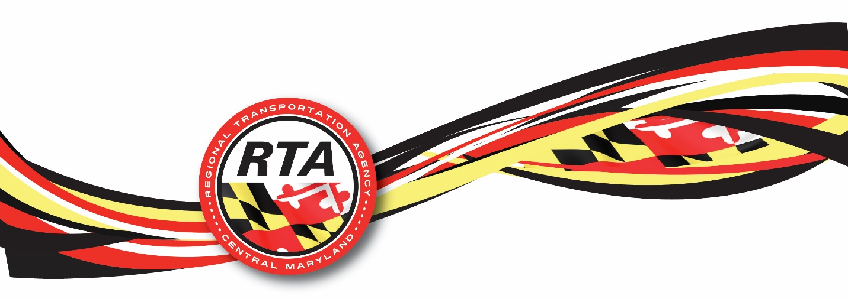

REQUEST FOR INFORMATION
(RFI)
DIGITAL ADVERTISING SOLUTIONS FOR TRANSIT SERVICES
REGIONAL TRANSPORTATION AGENCY OF CENTRAL MARYLAND (RTA)

Date issued:

SEPTEMBER 2nd, 2025

Request for Information (RFI) for Digital Advertising Services

INTRODUCTION
Transit Management of Central Maryland (hereinafter, TMCM), d/b/a Regional Transportation Agency of Central Maryland (RTA) is exploring revenue opportunities through digital advertising inside transit buses and is seeking information on current vendor capabilities. Responses may support future procurement or pilot implementation in accordance with local, state, and federal regulations. RTA appreciates your input and participation in this process.

BACKGROUND INFORMATION
Our organization provides and operates Fixed Route and Paratransit Transit Services on behalf of Howard, Anne Arundel, northern Prince George’s Counties, and the City of Laurel. RTA operates 15 fixed routes and ADA complementary paratransit and general paratransit (Howard County only) services throughout the service area. In this context, RTA is seeking to modernize its advertising program and leverage digital platforms to maximize revenue while ensuring a positive rider experience.

PURPOSE OF THE RFI:
The agency seeks solutions that:
- identify innovative digital advertising solutions applicable to transit environments.
- understand vendor capabilities, revenue models, and service offerings.
- explore integration of digital media inside transit buses.
- ensure compliance with relevant privacy laws, FTA rules, and local regulations.

This RFI is for information gathering only and not a solicitation for proposals. No contract will be awarded as a direct result of this process.

RESPONSE INFORMATION
- BUSINESS IDENTITY
Legal Entity Name: ______________________________________________________
DBE or/and MBE number (If available): _____________________________________
Address: ______________________________________________________________
- RESPONDENT CONTACT PERSON:
Name: ____________________________________ Title: _______________________
Phone number: _____________________________ E-mail: ______________________
- Provide a brief overview of your organization, its mission, and its current digital advertising solutions.
- Have you previously implemented digital advertising solutions for transit agencies or similar organizations? If yes, please provide examples and measurable outcomes.
- Can your platform integrate with on-board digital advertising displays?
- What revenue-sharing models do you offer for transit agencies, and can you provide projections based on our annual estimated ridership volume of one million?
- If your solution includes geofencing capabilities, what methods do you use to define geofenced zones, and how accurate is your target for moving vehicles such as buses?

GENERAL INFORMATION AND GUIDLINES
All responses to this RFI must be delivered electronically to ronaldo.joanis@transitrta.com and be no more than two pages in length. Any submitted information you believe to be confidential and exempt by law from public disclosure should be mentioned in the response document. The responses to this RFI will become RTA’s property and will be considered as confidential.
RTA will not reimburse costs associated with preparing any documents for this RFI. Comments must be provided by 4:00 P.M. on September 12th, 2025. The deadline to submit your response to this RFI is on September 17th, 2024, at 4:00 P.M. All questions must be directed at the email listed above.
Thank you for your interest.

For questions 3 to 7, please use your own format to respond. Keep your answers within 2 pages.

